Submission Guideline (Title, Bold, Font size 14)

Authora,*,Authorb
aAffiliation,Address, City,Country
E-mail address:xxx@mail.xxxx

bAffiliation,Address,City,Country
E-mail address:xxx@mail.xxxx

Abstract

The template serves as a submission guideline for authors interested to submit their papers to the International Conference on Contemporary Economic Issues 2014 (ICCEI 2014). The first page of the submitted paper should include the title of the paper and complete contact information of each author, which should include authors’ names, affiliations, full postal and email address. If there is more than one author for the paper, the corresponding authors hould be clearly marked with an asterisk (*). Three to five keywords must be given as below. Abstract must be written in English or Bahasa Malaysia not exceeding 300 words. Abstracts should clearly state aims of study, methodology used,results and conclusions.

Keywords:ICCEI 2014,economic growth, youth and society.

1. Introduction

Papers in various areas of contemporary economic issues that include but not limited to economic growth and development, quality of life and youth and society are invited to be submitted and presented at this conference.

  - MainText

The paper should be in single-column format, using a 12 point font with normal text spacing, and one-inch margins throughout the entire paper. Papers should not exceed 8 pages, all-inclusive.

  - Tables andFigures

All tables, figures, graphs, or appendices should have suitable titles. It is advised that tables supplement the discussion in the paper and not duplicating or repeating the text.

Table 1
Description of the samples
 | Coefficient | RRR | Z | P>z
Involved in sports activities
Gender | -0.2773445 | 0.7577934 | -0.53 | 0.597
Strata** | -1.236013 | 0.2905403 | -2.05 | 0.041
Marital status | 0.293131 | 1.340618 | 0.42 | 0.676
Age | -0.0233887 | 0.9768827 | -0.67 | 0.505
Source: Authors own estimates
**Statistically significant at 5 percent significance level
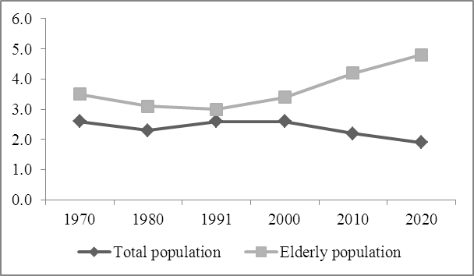
Figure1
Trend of elderly population, 1970 – 2020

2. Submissionand Proofreading

All papers should be sent electronically in MS Word-compatible file format to the ICCEI 2014 via the conference email at iccei2014@usm.my or directly to the conference chair at eieydda@usm.my. We take all the effort to acknowledge all submissions within 24 hours. Authors are responsible in proff reading their own papers. The conference secretariat is not responsible for any editing work for the paper. Papers with extensive errors (grammar and spelling) will be returned back to authors without review.

Articles previously published, under consideration by another conference or journals, and with pre-existing copyright may not be submitted for review and consideration.

3. Conclusion

Include conclusion and any policy implications here.

4. Acknowledgement

Acknowledgement is optional and should appear before references. The acknowledgement must be short and concise. Sponsorship and financial support acknowledgements should be included here. Acknowledging the contributions of other colleagues who are not included in the authorship of this paper is also added in this section. If no acknowledgement is necessary, this section should not appear in the paper.

5. References

References must be listed immediately following the conclusion or summary of the paper or after Acknowledgement. Please use Harvard referencing style, alphabetize by author and for each author list in chronological sequence. List the author’s names exactly as written in the source cited. (Please do NOT list references as footnotes at the end of each page).

